The photo below shows the major components of the system. From left to right:

1. 50 lb anchor
2. Small corrodible link
3. 10 lb weight
4. Small corrodible link
5. Buoy with counterweight (~50 lb)

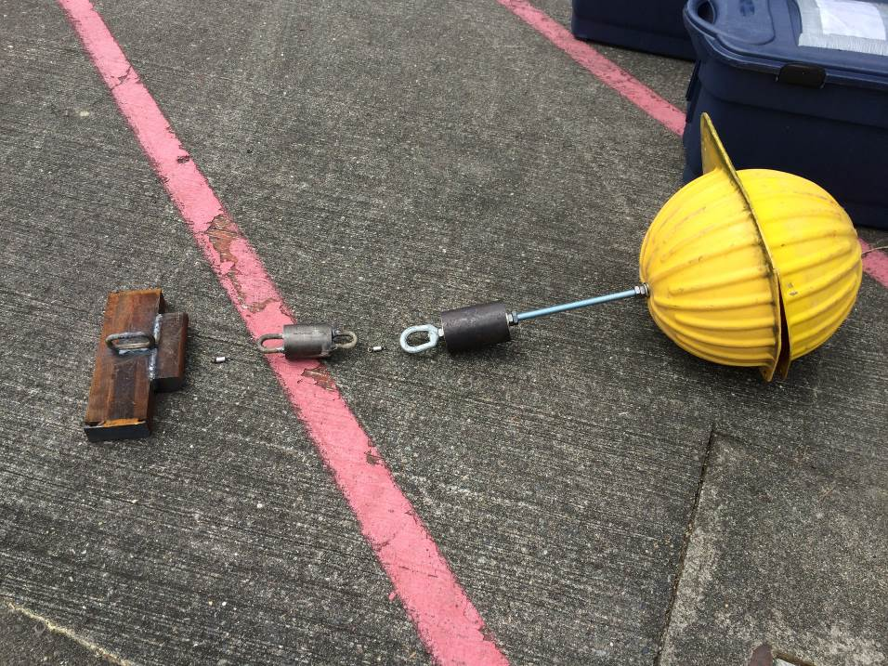

Instructions

1. **Remove top-half of hard hat.** 
   * Save all hardware and brackets.
2. **Attach satellite tag and mounting bracket to top of buoy.** 
   * Remove lock nut and washer, place mounting bracket on rod, replace lock nut and washer.
3. **Tighten all large nuts with 1-5/16” wrenches.** 
   * Including nuts holding the counter-weight and eye-nut.
4. **Attach top-half of hard hat.**
   * Add rubber spacers between the two halves if necessary to have clearance for the satellite tag.
   * The antenna will bend and the hard hat will have to be forced on – that is okay. Do your best to prevent excessive warping or stress on the hard hat.
   * Some longer nuts are in the bag of hardware if needed.
5. **Cut a hole for the satellite tag’s PAR sensor.**
   * This wasn’t possible before the buoys shipped because we didn’t have the tags yet/did not know the dimensions.
   * Cut a hole large enough to reach the sensor, while maintaining as much of the spherical shape of the hard-hat as possible. We want to make sure the sensor is below the level of the hard-hat so it is protected, allow ample light in so it works, but maintain the shape of the sphere so it can rotate freely under the ice. Use your best judgement. Sorry for the trouble ahead of time.
   * The tag also has depth and temperature probes. As long as the tag is protected, it may be better to have a larger hole (~2” dia.) so water can reach those as well.
   * It may be possible to cut the sphere with a sharp knife. It is relatively soft and tends to peel. Drilling carefully may prove difficult.
   * Please take a photo for reference
6. **Attach the name plate and pick point as before and tighten.**
7. **Attach anchors, extra weight, and releases to buoy.**
   * Refer to the diagram provided for layout.
   * Use parachute cord and tie bowlines between each element. 4-8 inches of cord between each element is desirable.
   * The shorter (smaller) release should be closer to the anchor.
8. **Lift the entire structure off the deck to ensure it holds.**
   * The weak elements of the chain are the timed releases. They have been welded and informally tested with 100+ lbs., but still unproven for a real deployment. It will be best if the whole structure is lifted off the deck briefly before deployment to check its integrity. A few extras are provided if any break (sub 7 day for 4 day and 10 day for 14 day releases if needed). Again, use your best judgement. **If we have any problem with this prototype, I expect it to be during this stage.**
   * The parachute cord will hold 800+ lbs. and provide some stretch while in tension.
9. **Deploy!**
   * It should be fine to deploy the unit with a single pick from the float. If there is a better way to reduce the strain on the equipment, feel free to use it.
   * At the least, lower the anchor into the water before releasing. Ideally lower as much of the buoy as possible before releasing. This will prevent any extra stress while it enters the water.
   * Keep the unit as controlled as possible to prevent large dynamic loads that could possibly break the timed releases.
   * Worst case scenario, the releases break during deployment and we lose the anchor/weight/buoy. If it’s possible to use some other weight onboard as an anchor and re-deploy then by all means do so (even if it doesn’t have the second weight attached). If that is not possible, please bring the buoy and satellite tag back. The sat tags cost ~$4,500 each and can be reused at a later date.
10. **Record**
    * Please record
      1. Location
      2. Time of satellite tag activation (when it gets wet)
      3. Time of deployment (if different)
      4. Depth at location
      5. Ice thickness/condition at location (photos would be great)



